17. ReactJS-HOL:
Create a react app with the name “fetchuserapp” & open it in the vs code.
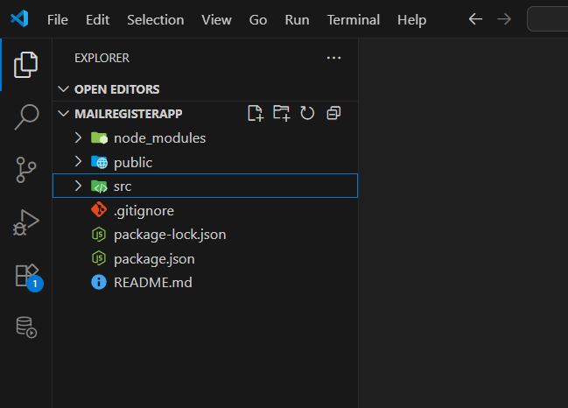
Getuser component:
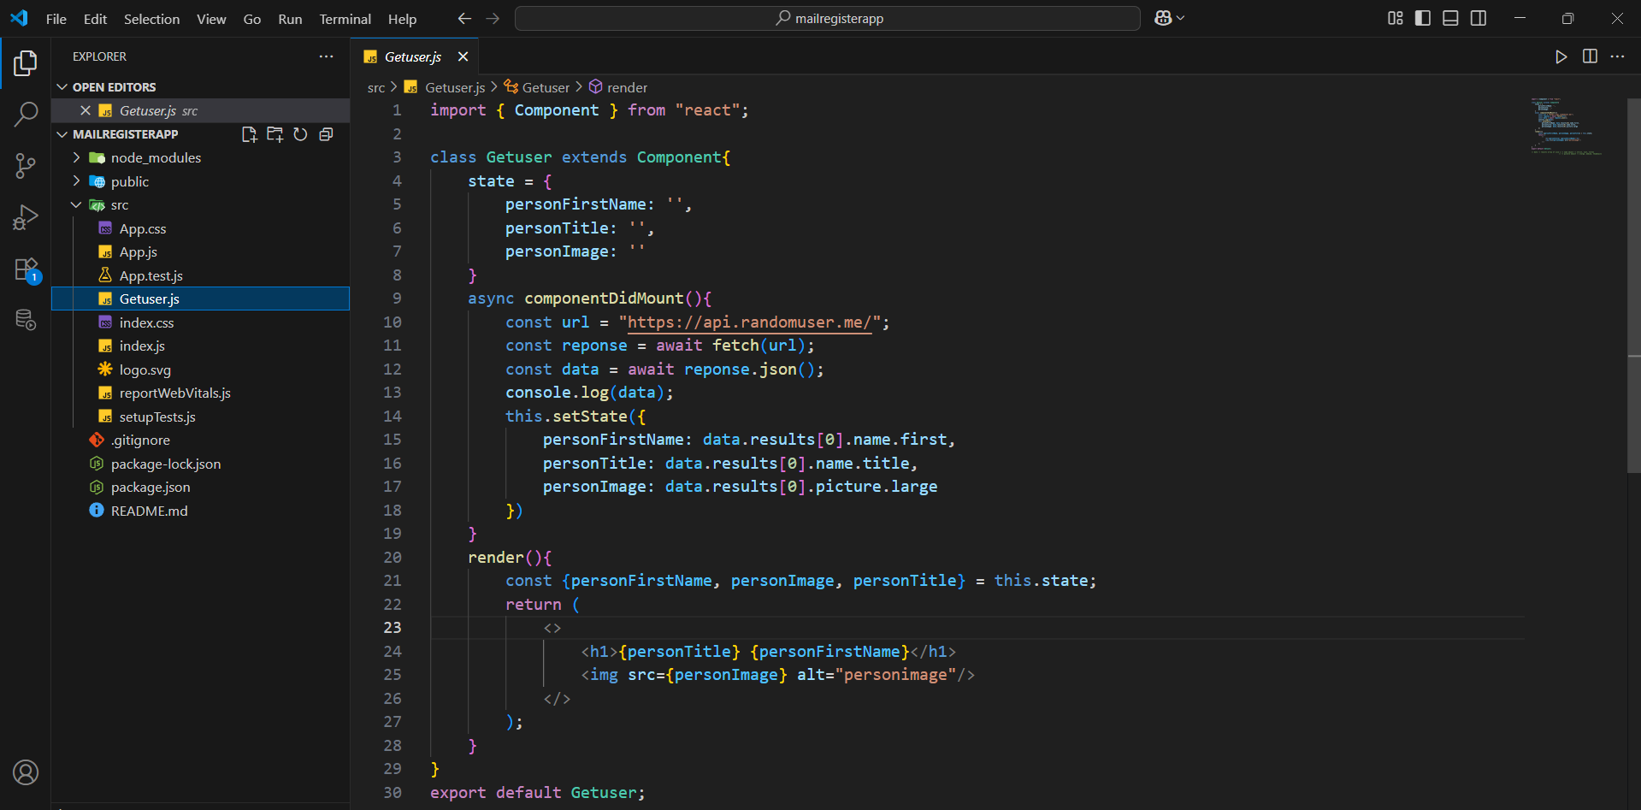
App component:
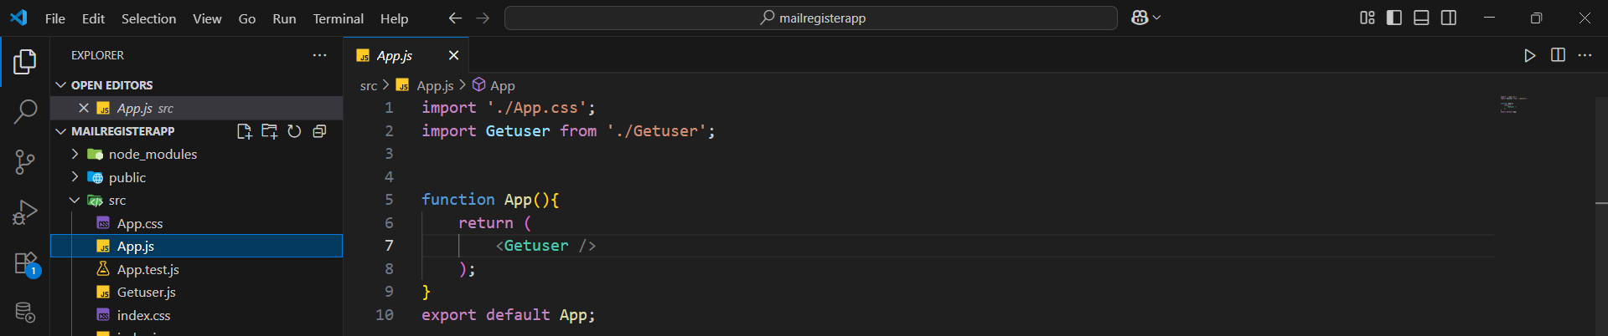

When we fetch to the url we get below json data that we can see by opening it in the incognito tab.
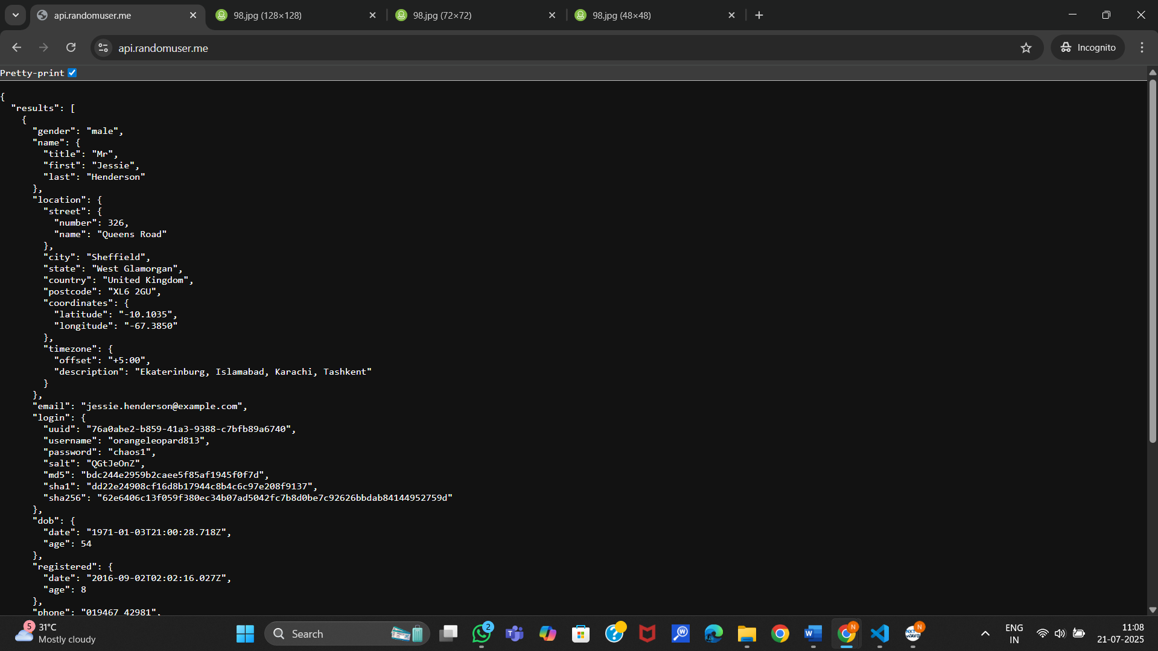
Why incognito because, we get antivirus pop ups when we open in normal tab.
Or else we can write a console log statement and print it to the console and we can see that in developer tools.
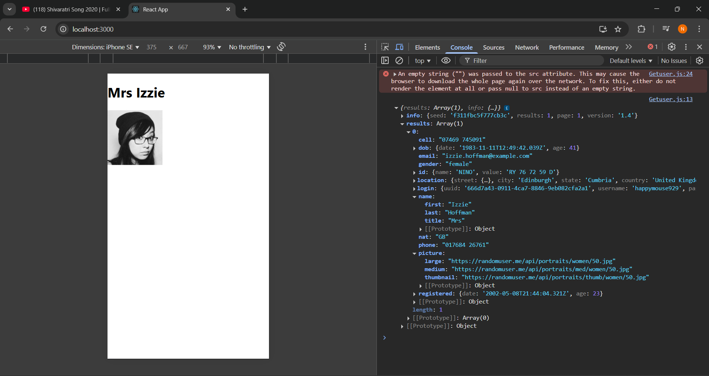
The data we need can be retrieved as follows

Output:
